**LiBook**

*Represents modern online librarywith simple and user-friendly UI to interact with information about books and authors.*

The goal of the system is to simplify the process of searching books and authorsfor user. The service provides quick access to the main information about books and their authors available across the system. The system allows to manage items (books and authors) in a really easy way using comfortable modern interface. In addition, amongst options available, an end user can add books to the wish list and find out where the books he/she likes is available to buy.Also users can leave comments to book which he/she like.

**Subsystems**

***BookSubsystem***

|  |  |  |  |  |  |  |
| --- | --- | --- | --- | --- | --- | --- |
| **№** | **Including Use Case** | **Role** | **Use Case** | **Description** | **Action Method** | **Tests** |
| BS1 | - | Admin | Edit book | Updateinformationaboutbooksuchasgeneralinformation (title, descriptionetc.), pictureanddataaboutauthors. | Edit(EditBookViewModel model) |  |
| BS2 | - | Add book | Create newbooksaddinggeneralinformation (title, descriptionetc.), picture. | Add(CreateBookViewModel model) |  |
| BS3 | - | Delete book | Deleteallinformationavailableaboutbook. Thisactioncannotbeundone. | Delete(DeleteBookViewModel model) |  |
| BS4 | Search item | Web Customer | Search book | Searchallinformationavailableaboutbook. | Search(SearchBookViewModel model) |  |

|  |  |  |  |  |  |  |
| --- | --- | --- | --- | --- | --- | --- |
| **№** | **Including Use Case** | **Role** | **Use Case** | **Description** | **Action Method** | **Tests** |
| AS1 | - | Admin | Edit author | Updateinformationaboutauthorsuchasgeneralinformation (first name, last nameetc.), pictureetc. | Edit(EditAuthorViewModel model) |  |
| AS2 | - | Add author | Createnewauthorsaddinggeneralinformation (title, descriptionetc.), picture. | Add(AddAuthorViewModel model) |  |
| AS3 | - | Delete author | Deleteallinformationavailableaboutauthor. Thisactioncannotbeundone. | Delete(DeleteAuthorViewModel model) |  |
| AS4 | Search item | Web Customer | Search author | Searchallinformationavailableaboutauthor. | Search(SearchAuthorViewModel model) |  |

***AuthorSubsystem***

***WishlistSubsystem***

|  |  |  |  |  |  |  |
| --- | --- | --- | --- | --- | --- | --- |
| **№** | **Including Use Case** | **Role** | **Use Case** | **Description** | **Action Method** | **Tests** |
| WS1 | - | Registered Customer | Add to wish list | Add books to the wish list | Add(AddToWishListViewModel model) |  |
| WS2 | - | Delete from wish list | Remove books from the wish list | Delete(DeleteFromWishListViewModel model) |  |
| WS3 | Add to Wish list | Add note | Add a note why this book should be in his/her wish list | AddNote(AddNoteViewModel model) |  |

***User Subsystem***

|  |  |  |  |  |  |
| --- | --- | --- | --- | --- | --- |
| **№** | **Role** | **Use Case** | **Description** | **Action Method** | **Tests** |
| US1 | Registered Customer | Log in | Authozation in system | LogIn(LogInViewModel model) |  |
| US2 | Log out | Log out from system | LogOut(LogOutViewModel model) |  |
| US3 | New Customer | Registration | Registration in sytem | Registration(RegistrationViewModel model) |  |

***Tests***

|  |  |  |  |
| --- | --- | --- | --- |
| **№** | **Test class** | **Test method** | **Code coverage** |
|  |  |  |  |
|  |  |  |  |

**Diagrams**

1. Use cases.
   1. General use case diagram

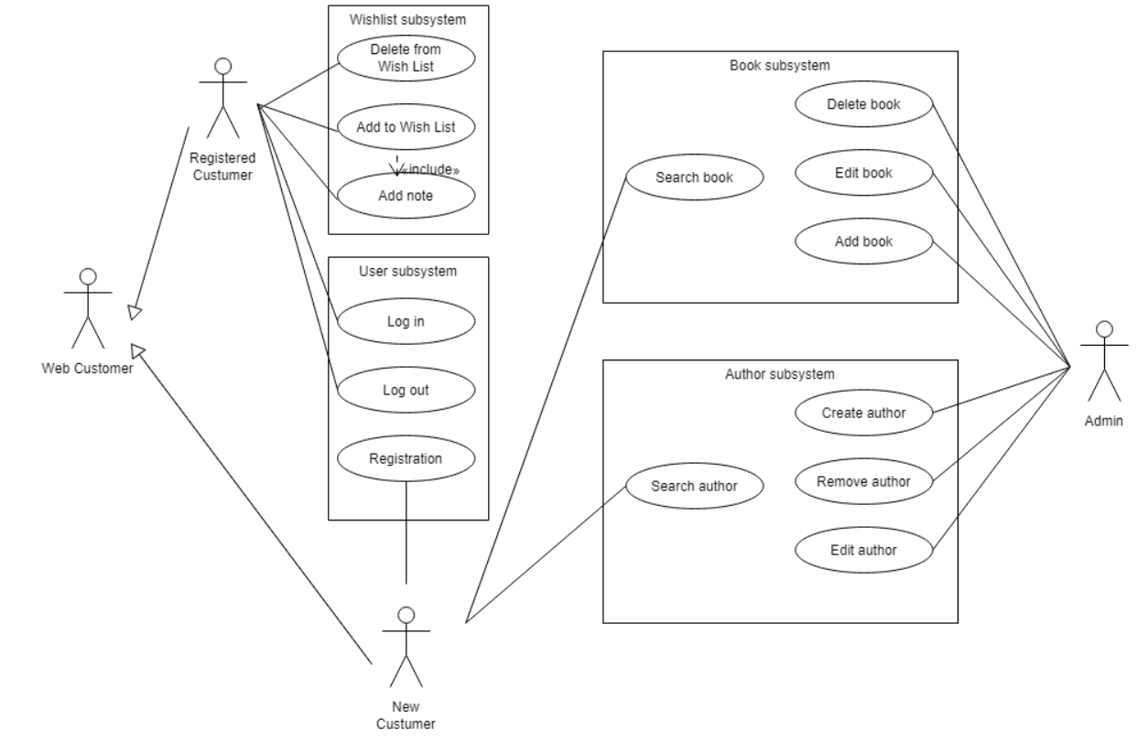

1.2 Use case forAdmin role

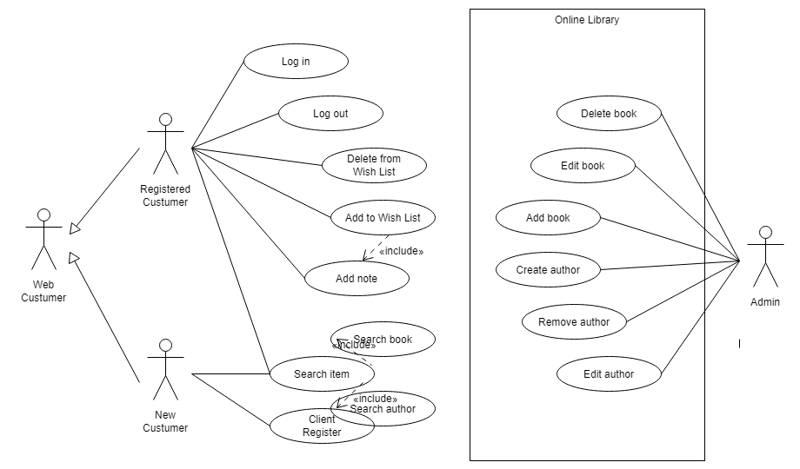

* 1. Use case forregistered user

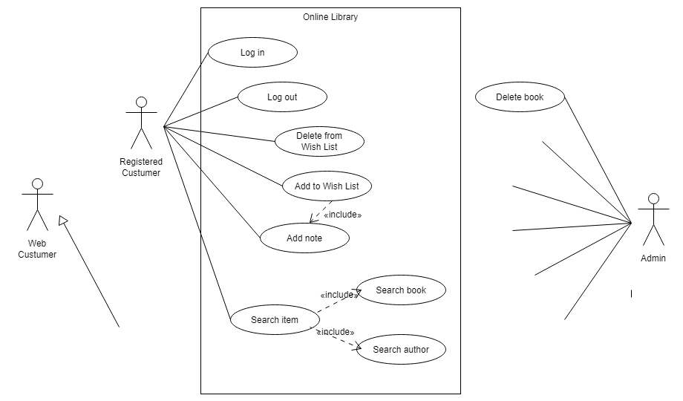

* 1. User case for guest

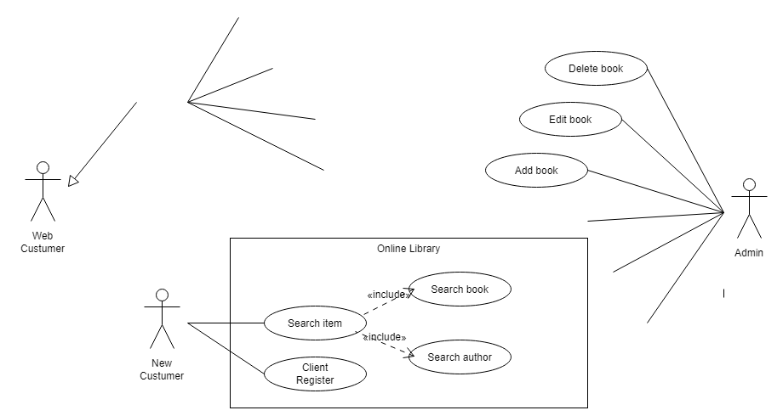

1. Sequence.

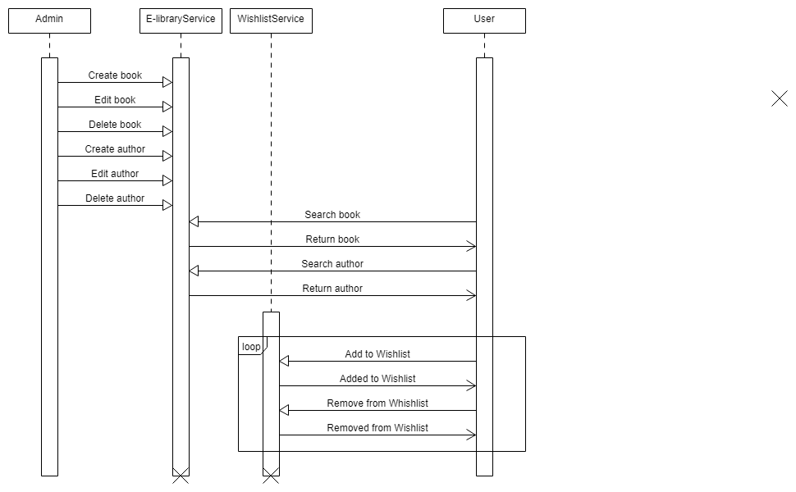

1. Class.

